**Location blocks:**

* Let’s say we give **/greet** to the URL of nginx, it can’t read it and gives 404 error as below.

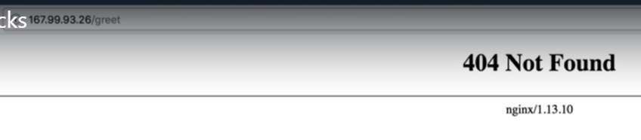

* We need to add that location context inside server context of config file as below.

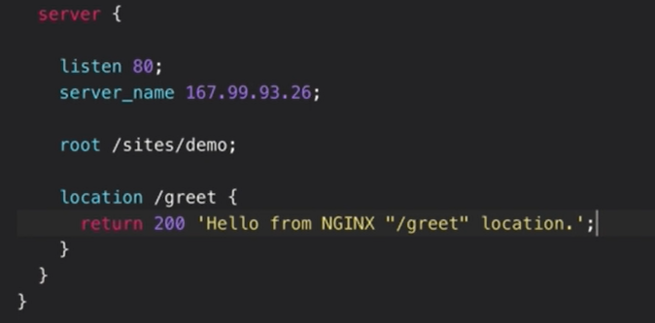

* Save and reload the configuration. Now we can get that response as below.

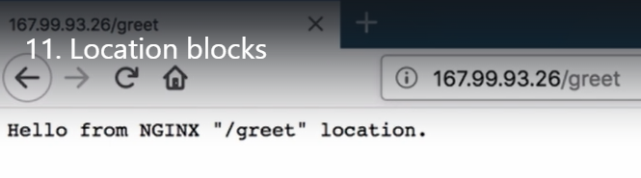

* We can add prefix or exact matches as below.

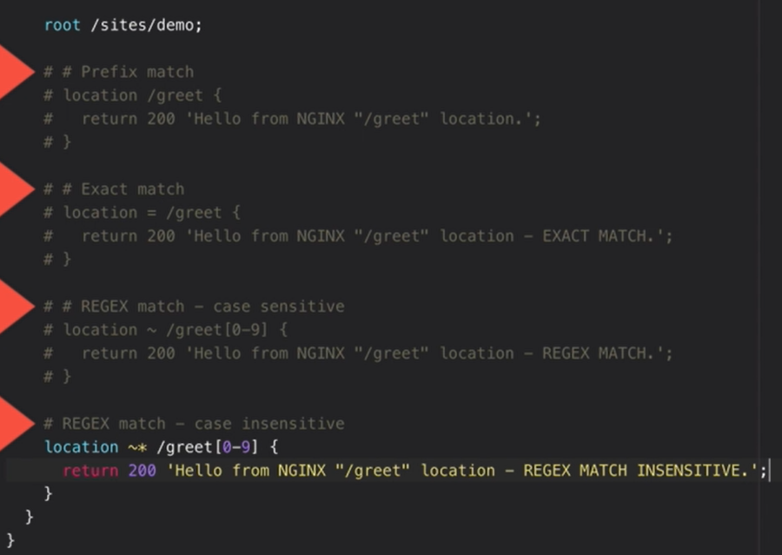

* If we give prefix, then any context starts with the location we give in config file will works. As above **“/greetings”** will also works same as **“/greet”**
* **“Exact match”** woks only if the context of url be used with same configuration in the config file
* **“REGEX match”** is to add numeric value to the context, as above if we use the context in URL like **“greet2” or “greet3”** will work the same way.
* But it is case sensitive. And if we want to use it with case insensitive. Then we need to use **“~*”** symbol as above.

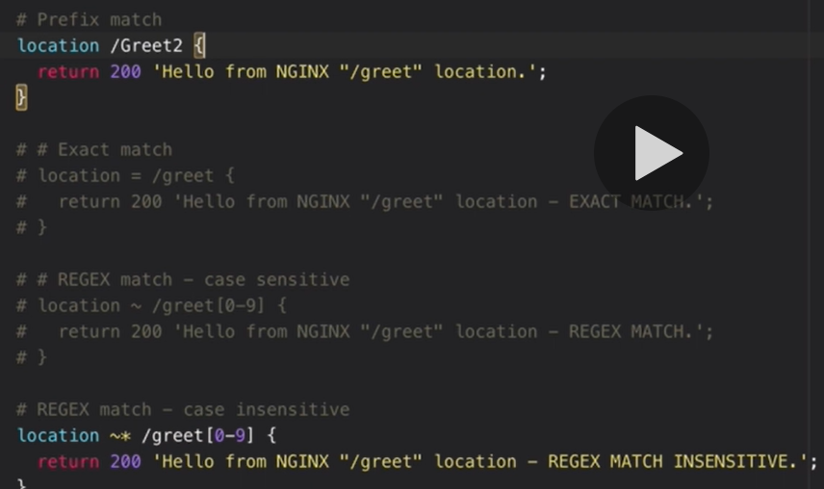

* So as above, if we add prefix match and **“REGEX case insensitive”** match as same and access the URL with **“Greet2”** context. Then the nginx will match the requests to REGEX match.

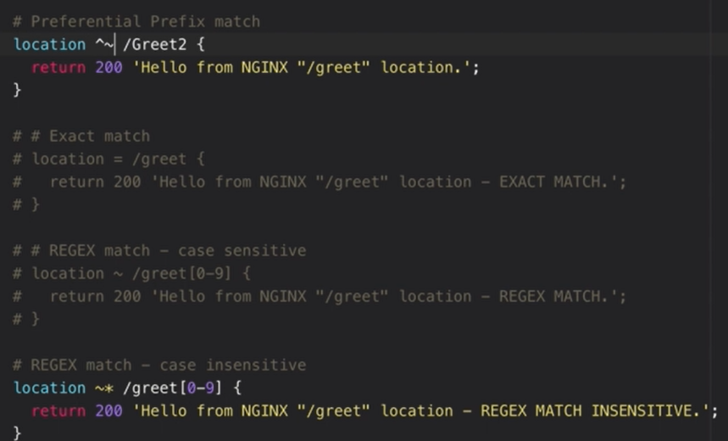

* If we add **“preferential prefix”** match as above, then nginx will match the requests this one. This is the same as regular one but more important.
* It is important to understand the priority in which the nginx matched requests first as below.

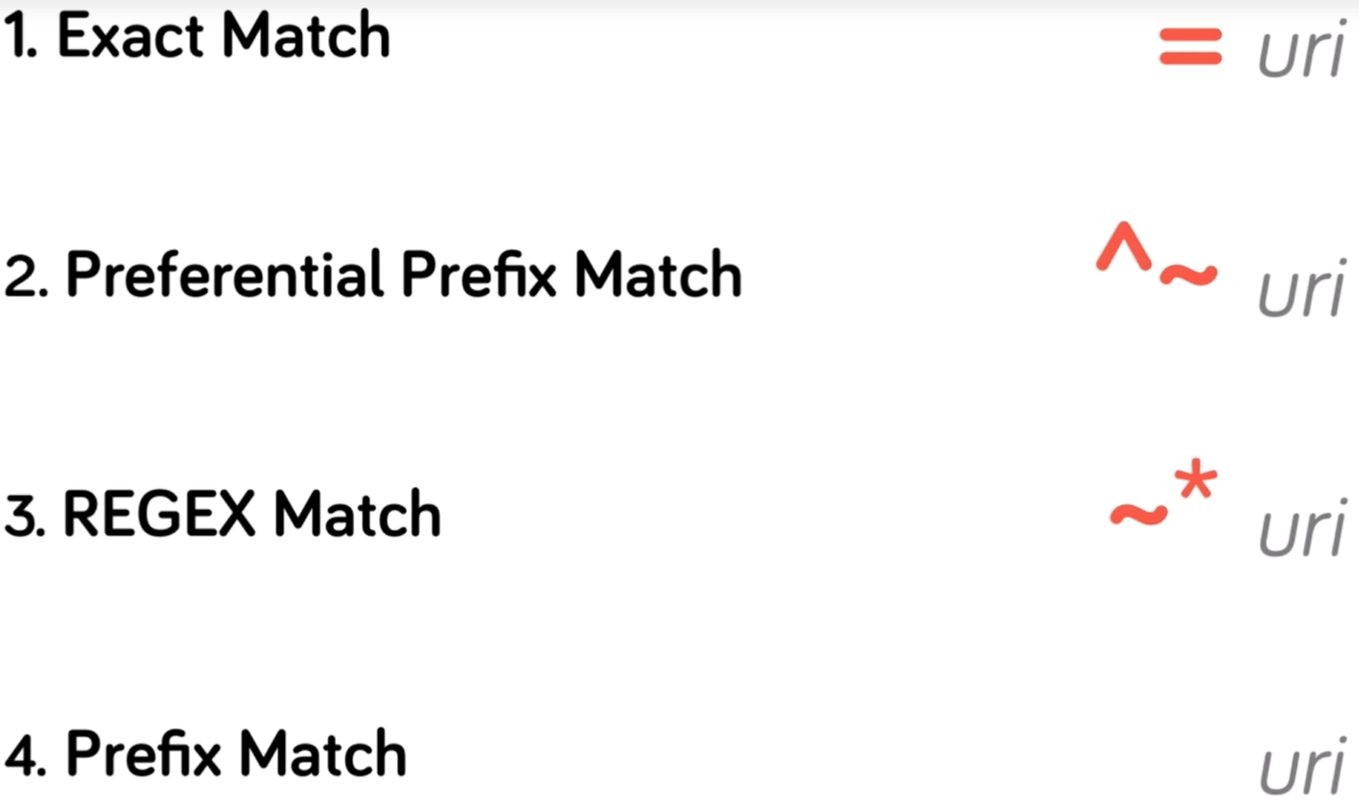

* First preference will be for the exact march, then the preferential prefix match which is same as regular but a bit more prioritized.

